
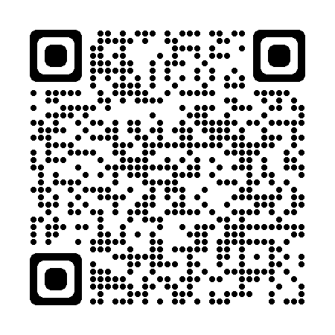
COACH’S CHECKLIST
Ysf site
Novosel INITIAL
COACH: _________________
☐ | FINGERPRINTS  (Every 5 years)  Date: __________ |  | ☐ | DA Form 4162: Volunteer Service Record  Date: ________
 |  |  | ☐ | CYS Discipline Policy  Date: ________
☐ | PART 1:  BACKGROUND |  | ☐ | CYS Touch Policy  Date: ________
☐ | Form DD 2981  Date: ________ |  | ☐ | CYS Privacy Policy  Date: ________
☐ | Resume/Application  Date: ________ |  | ☐ | CYS Confidentiality Policy  Date: ________
☐ | CYS Coach Job Description  Date: ________ |  | ☐ | CYS Statement of Understanding Policy  Date: ________
☐ | DA Form 5018  Date: ________ |  | ☐ | TWO References (Non-related)
 |  |  | ☐ | Coaches Orientation Acknowledgement  Date: ________
☐ | PART 2: BACKGROUND |  | ☐ | NAYS Coaches Code of Ethics/ Exam  Date: ________
☐ | Prospective Coach Application  Date: ________ |  | ☐ | DD Form 2793: Volunteer Agreement  Date: ________
☐ | DA Form 5018-R: ADAPCP Client’s Consent  Date: ________ |  | ☐ | NAYS Sport-Specific training  Date: _______  (Complete prior to coaching each sport)
☐ | Dep. Of Army Release/ Consent Statement  Date: ________
☐ | OTHER REQUIREMENTS |  | ☐ | IN-PERSON
☐ | Immunizations: A current Flu vaccination OR waiver  Date:_________ |  | ☐ | Child Abuse and Prevention  Date: ________
☐ | Individual Development Plan (IDP)  Signed & Completed
 |  |  | ☐ | BACKGROUND CHECK
☐ | ONLINE TRAINING |  | ☐ | Background Check Approval  Date:________
☐ | First Aid/CPR (Valid for 2 years)  OR other acceptable lifesaving training (i.e. CLS-Does not expire)  Date:___________ |  | ☐ | Background Check Recertification  (Valid for 5 years)  Date:________
☐ | NAYS Mental Health Challenges (print/email certificate)  Date: _______
☐ | NAYS Concussion  Date: _______
☐ | NAYS Coaching Youth Sports  Date:________
☐ | NAYS Basic Youth Sports Safety and First Aid  Date:________

