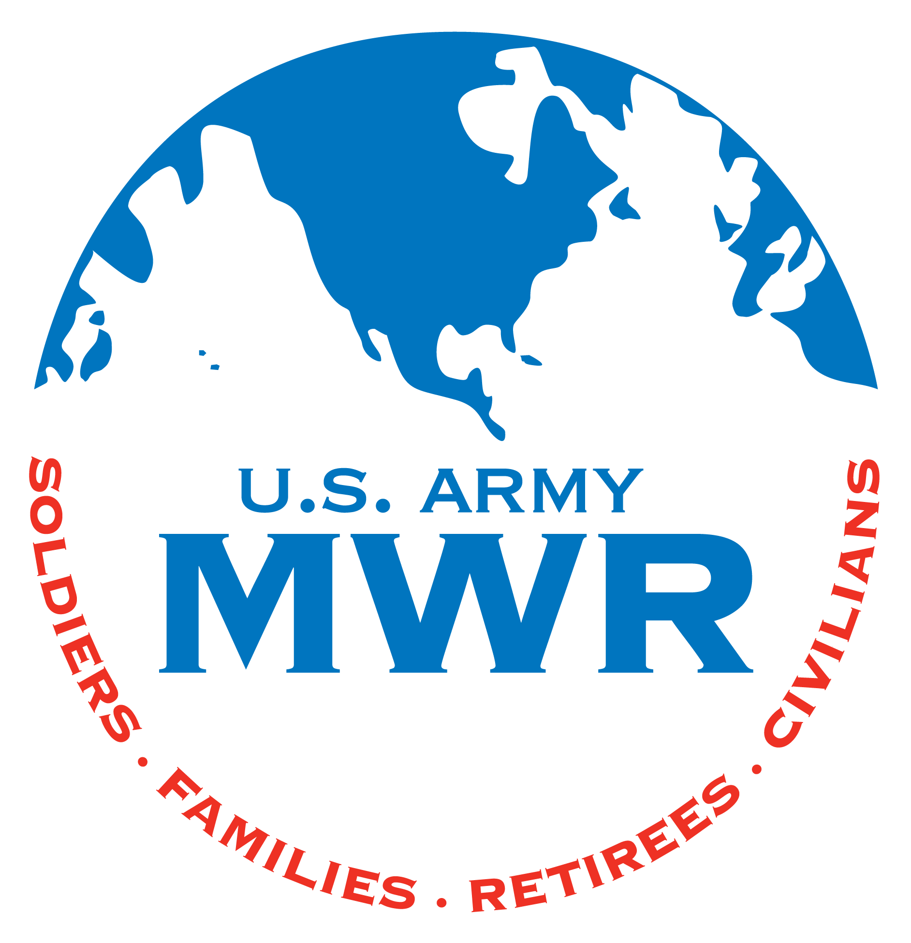
Lake Tholocco Sprint Triathlon
BIB NUMBER
(Staff only)

Saturday, June 15th 2024
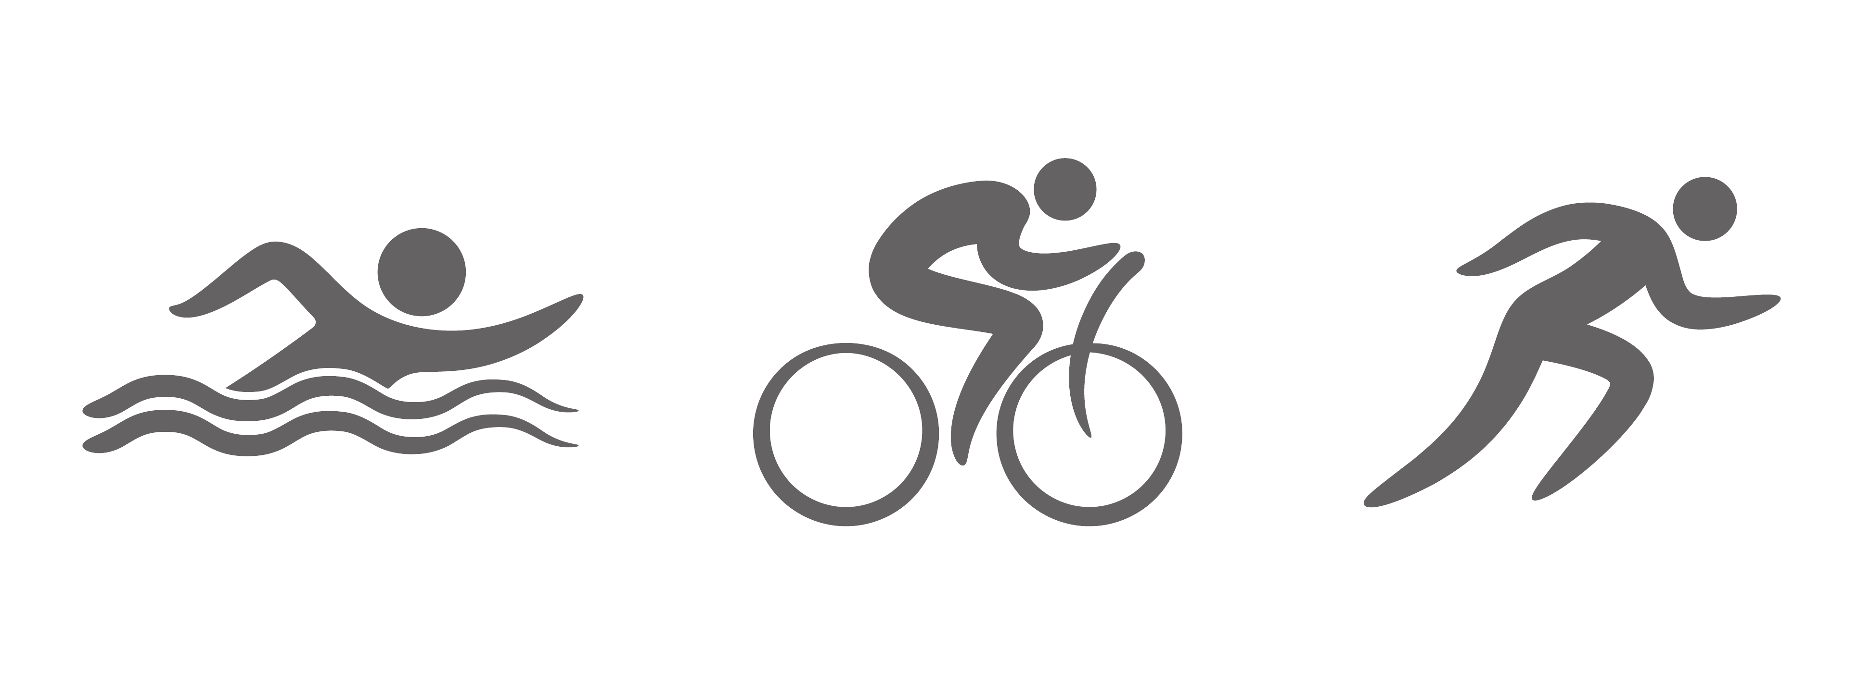
Entry Form

Circle Shirt Size: S M L XL (First Come First Serve for sizes and while supplies last)

Circle Race: Individual Relay Team (2 or 3 competitors per team) Please list name on each event

Relay Team Name: _________________________________________

SWIM:______________________BIKE:_____________________ Run:_____________________

RELEASE AND HOLD HARMLESS AGREEMENT
DEPARTMENT OF FAMILY AND MORALE, WELFARE, AND RECREATION
I know that participating in a Triathlon is a potentially hazardous activity. I should not enter or participate unless I am medically able and properly trained. I agree to abide by any decision of a race official relative to my ability to safely complete the Triathlon. I assume all risks associated with participation in this event including, but not limited to, falls, contact with other participants, the effects of the weather, including high heat and-or humidity, traffic, and the conditions of the road, all such risks being known and appreciated by me. Having read this waiver and knowing these facts and in consideration of your accepting my entry, I, for myself and anyone entitled to act on my behalf, waive and release the Department of Family and Morale, Welfare, and Recreation Fund and the United States Government from any liabilities or claims arising from my own participation. I agree that I will never prosecute or in any way aid in the prosecuting of any demand, claim or suit against the United States Government for and loss, damage or injury to my person or property that may occur from any cause whatsoever as a result of taking part in this activity. I also understand and agree that I may be held liable for any damage or loss to the United States Government that is caused by my gross negligence, willful misconduct or fraud. I grant Fort Novosel Family & MWR, its representatives and employees permission to take photographs of me and my property. I authorize Fort Novosel Family & MWR, the irrevocable and unrestricted right of copyright, use and publishing of said images in print, electronically, or in any other medium. I agree that Fort Novosel Family & MWR may use such photographs of me with or without my name and for any lawful purpose, including but not limited to publicity, illustration, advertising and web content. I hereby release photographer and Family & MWR from all claims and liability relating to said photographs.
I have read and understand the above:

Last Name: ____________________________________ First Name: ________________________________

Gender: M or F Birthdate: ___________ Age (as of June 15th 2024) ___________

Email: ______________________________________________ Phone: _____________________________

Signature: ____________________________________________________
Parent or Guardian must sign if under 18

Information has been verified by staff  Form is complete | ______________________ _______  Staff name Date received
Please do not write below this line. To be completed by MWR Staff

